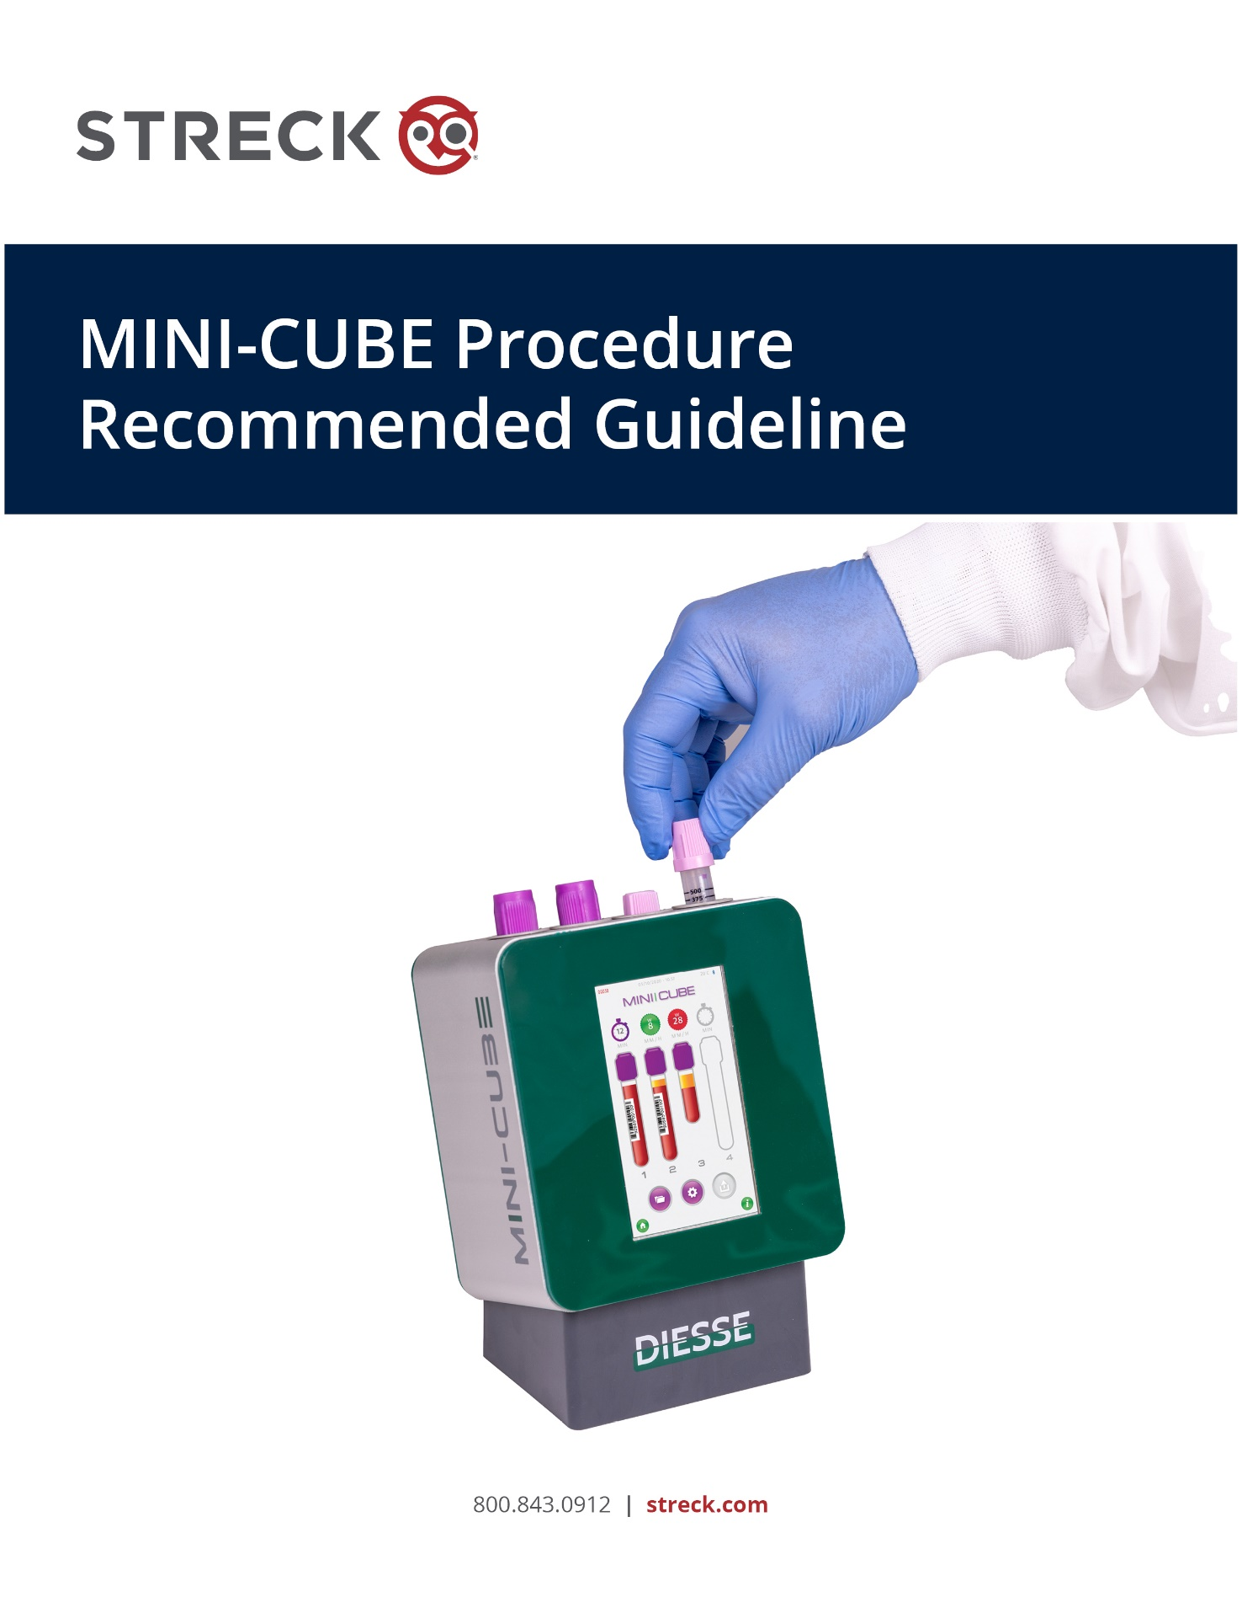
Source: Streck
Streck provides this template for laboratories to incorporate into their internal protocol.
Streck assumes no responsibility for protocols generated from this template.

Attention
Upon receipt of equipment, new MINI-CUBE users should contact Streck Technical Services at 800.843.0912 (x7510) or technicalservices@streck.com for assistance with instrument setup and best practices.

Purpose
The basic principle of the erythrocyte sedimentation rate (ESR) test is that anticoagulated blood is placed in a vertical column that remains undisturbed for a specified amount of time. At the conclusion of the test, the distance the red cells have settled is measured in mm per hour (Westergren method).

Red cell sedimentation is accelerated by an increase in the plasma concentration of “acute phase proteins,” which are increased in acute tissue damage, chronic inflammation, chronic infection, and pregnancy. The ESR reflects both the increase in certain accelerating proteins, such as fibrinogen and gamma globulins, and the decrease in retarding proteins, such as albumin. Conditions that promote the formation of rouleaux produce an elevated ESR result.

The MINI-CUBE is an automated ESR analyzer incorporating new technology that accurately and precisely measures the sedimentation rate of erythrocytes in standard 13 x 75 mm K₂ or K₃EDTA blood collection tubes with Hemogard or conventional stoppers, or K₂EDTA Microtainer tubes (BD®). The results are recorded as mm per hour in only 20 minutes or 14 minutes for Microtainer tubes. The instrument compensates for temperatures above 18 °C according to Manley’s Nomogram and offers the ability to adjust for patient Hematocrit values <40%.

Scope
Insert laboratory personnel performing testing.

Specimen Requirements
13x75 mm standard K₂EDTA or K₃EDTA blood collection tubes; Acceptable sample volume: 2.0 mL - 4.0 mL.

BD Microtainer or BD Microtainer® MAP K₂EDTA blood collection tubes; Minimum sample volume: 500 µL.

Refer to CLSI guidelines for EDTA tube stability.

NOTE: The MINI-CUBE can accept 13X75 mm EDTA sample tubes with a maximum of one secondary patient label over the manufacturer’s label with at least a 5 mm label-free gap.

Insert laboratory blood collection procedure.

Insert laboratory storage recommendations.

Equipment
MINI-CUBE

Safety Requirements
Insert laboratory safety guideline.

Reagents/Special Supplies:
Transponder

Home Screen
The HOME screen provides three options:
- START – enter analysis mode.
- ARCHIVE – access archived QC and patient results.
- SETTINGS – review/edit system settings.

Procedure

Loading a Transponder
- From the HOME screen, select the SETTINGS icon.
- Navigate to page 2 in SETTINGS and select REFILL to load more tests on the MINI-CUBE.
- A window reading “Insert CHECK DEVICE and press CHECK key” will open.
- Gently lift or lay the instrument down with the display screen facing up and insert the transponder tube with the cap to the left.
- With the instrument upright, press CHECK, and follow the instructions on the screen.
- The number of remaining tests will update in the upper left corner of the screen.

Quality Control
It is recommended to run 2 levels of control every day the MINI-CUBE is in use.

Insert laboratory QC recommendations and procedures.

Registering a New QC Lot
Only one control lot may be registered in the QC file at a time. Control data from the previous lot will be saved in the QC Archive.
- From the HOME screen, select the SETTINGS icon.
- Navigate to page 2 in SETTINGS and Select QC to open the QC SETTINGS screen.
- (Optional) With the NORM button selected, touch the Name box. A virtual keypad will be displayed. Type in Level 1 or however you want to distinguish ESR-Chex® Plus Level 1. Touch the return key on the keypad to have the keypad disappear.
- Scan the ESR-Chex Plus Level 1 barcode found on the ESR-Chex Plus Assay sheet. The barcode, lot number, expiration date and control range fields will auto-populate.
- Repeat the process for ESR-Chex Plus Level 2 using the ABN button.
- (Alternatively, one can manually enter the information listed on the control assay sheet into these fields.)
- Press the RETURN arrow on the lower left corner of the screen to exit QC SETTINGS.
- Press YES to save the new settings, or NO to discard the new settings.

Running QC Samples
- From the HOME screen, select the START icon.
- Scan the barcode on the Assay sheet for the registered lot of ESR-Chex Plus.
- A window titled “Inserted QC Code” that contains the registered QC lot data will open.
- Press YES to run the tube as a QC sample, or NO to run the tube as a patient sample.
- Insert the QC vial into any available well with the label-free gap facing the dot on the right side of the well.

- The control result and the expected range will automatically print when the test is complete. QC printouts will indicate PASS/FAIL with each result. If the result is outside the expected range, the result on the MINI-CUBE screen will be highlighted in red. If the result is within the expected range, the result on the MINI-CUBE screen will be highlighted in green.

Viewing QC Results
The QC Archive stores up to 5,000 QC results per level. Lot-specific statistical reports can be generated from these archive files. When the QC Archive reaches capacity, the oldest value will be deleted, and the newest value will be added.
- From the HOME screen, select the ARCHIVE icon.
- From the ARCHIVE menu, select the QC icon to view all available QC data in the archive list.
- To reprint QC results:
  - Select an individual result in the QC Archive list.
  - Press the DOWNLOAD icon and select PRINT to reprint the individual result, or PRINT LIST to print the entire QC archive.
- To view details for an individual QC result:
  - Press and hold an individual result in the QC Archive list.
  - Press the CHART icon to view the Levey-Jennings chart and statistical data about the entire lot.
  - Press the DOWNLOAD icon to reprint the result.
- To view details for a specific QC lot:
  - Select an individual QC result from the desired lot in the QC Archive list.
  - Press the CHART icon to view the Levey-Jennings chart and statistical data about the entire lot.
  - From the Levey-Jennings Chart, press the DOWNLOAD icon to print the collection of data in the chart.
- To delete QC results:
  - Select an individual result in the QC Archive list.
  - Press the DOWNLOAD icon and select DELETE to permanently remove an individual QC result.

Sample Mixing Procedure
The sample mixing procedure is critical for accurate results.
- Ensure that the sample is at room temperature. If previously refrigerated, allow to warm to room temperature for 15 minutes prior to analysis.
- Immediately before starting the analysis, gently and completely invert the EDTA tube end-over-end 10 to 12 times to resuspend the sample. Do not shake or agitate the sample vigorously, as this could cause bubbles or hemolysis.
- Examine the sample to ensure bubbles are not present at the meniscus, as this could interfere with the sample reading.

Enter the Sample ID Code
- Enter the Sample ID Code by using the barcode scanner:
- From the START screen, scan the patient barcode with the barcode scanner.
- A window titled “New Sample” will open with the barcode information displayed in the Sample ID field.
- Insert the well-mixed patient sample into any available well with the label-free gap facing the dot on the right side of the well.
- A full-color image of the tube containing a barcode image will appear on the screen and testing will automatically initiate.
- Enter the Sample ID manually:
- From the START screen, press the tube image on the screen.
- Press the “Sample ID” field to open a keyboard and manually enter the sample ID.
- Press the ENTER arrow to close the keyboard.
- Insert the well-mixed patient sample into any available well with the label-free gap facing the dot on the right side of the well.
- A barcode image will appear on the tube indicating that it contains a Sample ID, and testing will initiate.

Reporting Results
It is good laboratory practice to visually correlate the level of sedimentation in the sample tube to the printed result. The MINI-CUBE automatically sends the result to the printer and data output port and displays an image of the sample tested on the screen.

Reportable Range:
13x75 mm EDTA tubes (2.0 mL – 4.0 mL): 1 – 140 mm/hr.
Samples with a result greater than 140 mm/hr should be reported as “>140 mm/hr.”

BD Microtainer or BD Microtainer MAP EDTA tubes (500 µL) : 1 – 100 mm/hr.
Samples with a result greater than 100 mm/hr should be reported as “>100 mm/hr.”

If the result is below or equal to the threshold value programmed in the SETTINGS menu, the result on the MINI-CUBE screen will be highlighted in green. If the result is higher than the threshold, the result on the MINI-CUBE screen will be highlighted in red.

Samples run in BD Microtainer or BD Microtainer MAP tubes will display an image of a small tube on the screen. In addition, the BD Microtainer MAP tube will have an “M” on tube cap during analysis. “PEDIATRIC” will be indicated on the sample printout. In the RESULTS Archive, a subscript “P” will be displayed immediately to the right of the ESR result.

The RESULTS Archive stores up to 5,000 patient results. When the RESULTS Archive reaches capacity, the oldest value will be deleted, and the newest value will be added.

Hematocrit Adjustment
The MINI-CUBE contains the option to apply an adjustment to ESR results for patient hematocrit (HCT) values <40%.
- From the HOME screen, select the ARCHIVE icon.
- From the ARCHIVE menu, select the RESULTS icon to view all available patient data in the archive list.
- Press and hold the desired patient result to open a detailed record of the sample result.
- Press the HCT field to open a keypad and manually enter the HCT value.
- Press the ENTER arrow to close the keypad.
- Press the RETURN arrow on the lower left corner of the screen to save the HCT adjustment.
- The adjusted ESR result will override the original ESR result, and a superscript “H” will be displayed immediately to the right of the ESR result.
- The HCT value may be deleted to display the original ESR result.

Insert laboratory data filing procedures.

Limitations of the Procedure
See the MINI-CUBE User Manual for guidance on abnormal samples (icteric, lipemic, etc.).

Preventative Maintenance
NOTE: Always turn off the MINI-CUBE and disconnect it from the power source before performing any type of maintenance.
- Weekly
  - Perform a power cycle once a week by turning off the analyzer, leaving it off for at least 30 seconds and powering it back on.
- As needed, wipe the outer surface of the instrument with 70% isopropyl alcohol and clean the screen with a microfiber cloth.
- If an internal spillage has occurred, contact Streck Technical Services at 800.843.0912 or technicalservices@streck.com for further instruction.

References
- MINI-CUBE User Manual, streck.com.
- Clinical and Laboratory Standards Institute, H02, Procedures for the erythrocyte sedimentation rate test. Approved Standard – Fifth Edition.

